Victorian Government Baby Bundle
Online Portal for Hospitals
USER GUIDE
Contents
Background 1
Introduction to the Online Portal 1
Login 2
1. Messages 4
2. Standing Orders 4
3. Supply Levels 5
4. Planned Deliveries 5
5. Distributor Details 6
Offering

Background
From July 2019, the Victorian government will offer first-time parents and carers a bundle of nursery essentials to support the health, development and wellbeing of their babies. All first-time Victorian families are eligible provided their first baby is born during or after July 2019. First-time foster and adoptive parents/carers with babies up to three months of age are also eligible to receive a baby bundle.

Hospitals play a vital role to present the baby bundle to eligible families. Hospitals should maintain a monthly supply (or otherwise as arranged), which are to be presented to families during their stay.

Introduction to the Online Portal
Welcome to the Baby Bundle Online Portal. This portal is the first step to providing Victorian baby bundles to hospitals. This is your single location to:
- Send us a message, and view a history of messages sent
- view regular standing orders and request any amendments
- view delivery address & contact details, and update these if needed
- view your upcoming deliveries and edit if needed

Overleaf you’ll see an example of what the Portal looks like.

Should you have any questions or need any help or support, we are here to help you.

Email: victoriababy@baobag.com.au

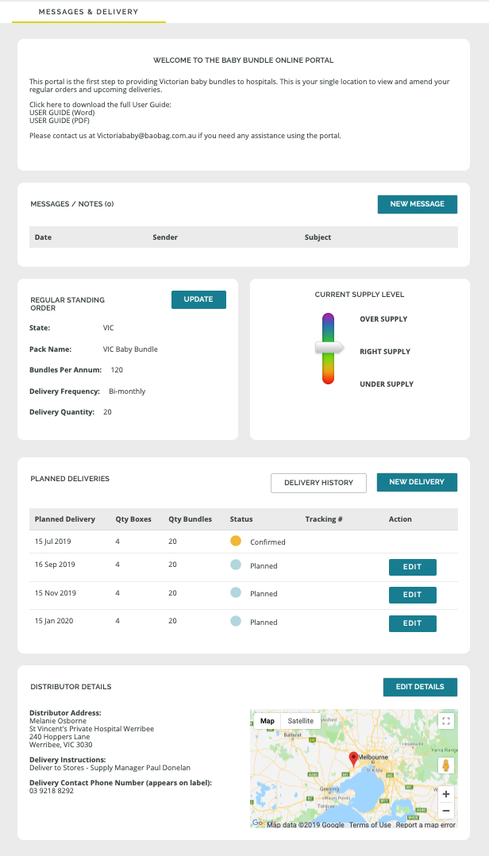

Login
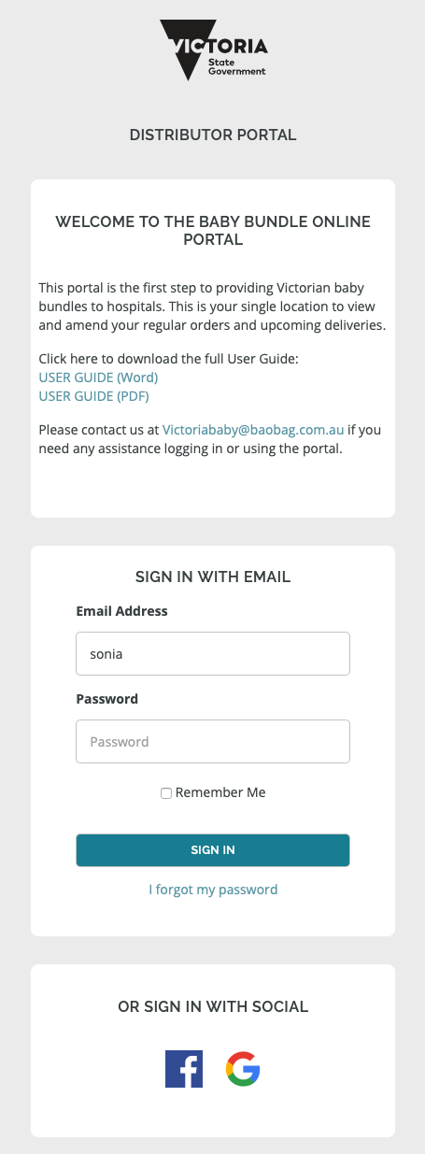
First we need to set you up with access to the portal. We can either issue you with a username and password or - if you don't want to have to remember a new password - we can grant you access via an existing social login such as google or facebook. You can assign multiple contacts to access your portal if you need.
If you don't already have access, please email Victoriababy@baobag.com.au with the following details and our team will be in touch to get you set up:
- name,
- role,
- contact details; and
- the name and delivery address of the hospital you are ordering on behalf of.
You will then be sent an email with your access details.

1. Messages
This is where you can see any communications we've had with you in one place. You can also send us a new message from here by clicking on the blue button.
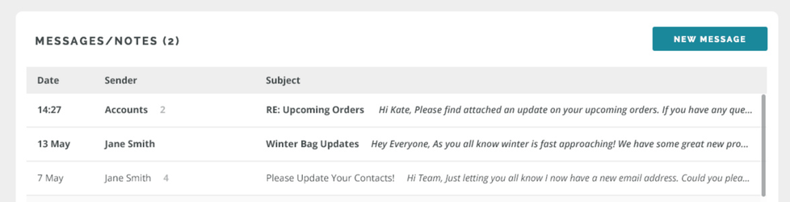

2. Standing Orders
This is where you can see how many baby bundles you are scheduled to receive with each delivery, and the delivery frequency. The calculation is based on the number of bundles you require per annum to hand out to first time parents. If you find the supply on your current standing order is not quite right, you can request changes to this by clicking on the blue "Update" button.
Note that there are 5 bundles per carton, and each bundle weighs just over 2kg. The carton dimensions are 53cm H x 44cm W x 35cm D. We understand storage pressures only too well, and so offer flexibility when it comes to how often you receive deliveries. Just note, however, that there is a minimum delivery quantity of 4 cartons / 20 bundles.

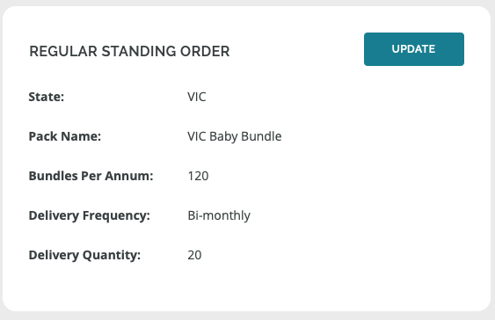

3. Supply Levels
This is where you can provide us with a quick health check review on your supply levels. Are we sending you too many bundles? Not enough? Or is it just right? Please channel your inner Goldilocks and adjust the dial as necessary. If supply levels aren’t quite right, then this will trigger a message to our team to review the numbers with you.

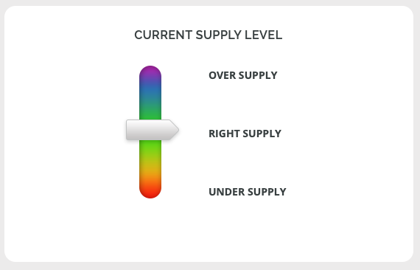

4. Planned Deliveries
This section shows your delivery schedule. You can edit a planned delivery if you need to skip it or change the quantity, right up until it moves to Confirmed status. Tracking details are provided for deliveries that have already been dispatched.
You can also request a new delivery if you've run out of stock and can't wait for your next scheduled delivery.

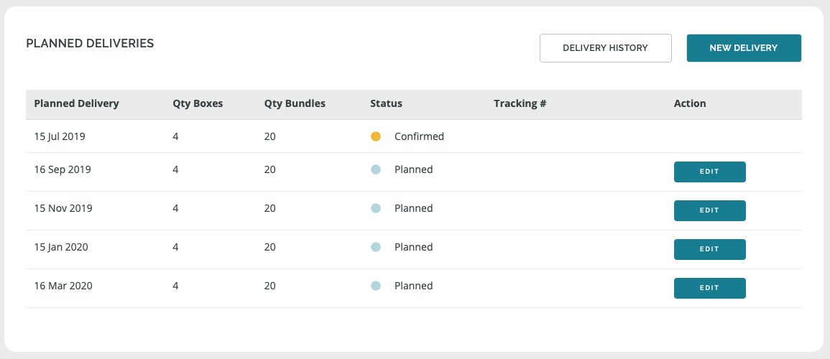

5. Distributor Details
This section is what appears on the delivery labels for the courier. You can amend this at any time by clicking on the blue button.

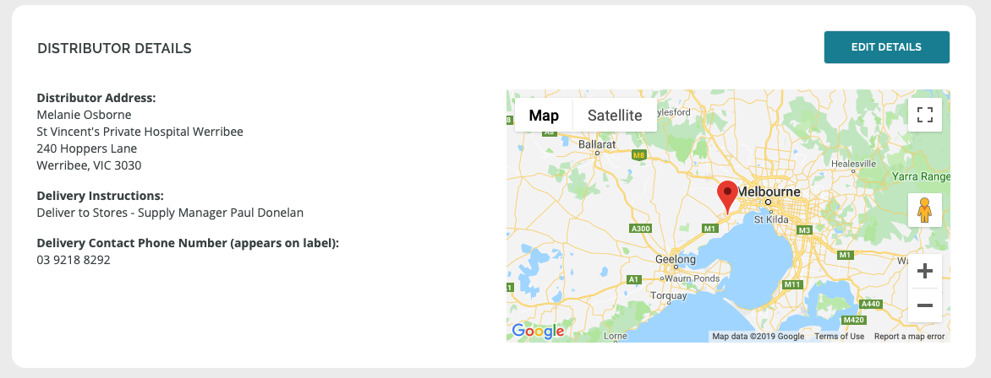

Authorised and published by the Victorian Government, 1 Treasury Place, Melbourne.
© State of Victoria, Australia, Department of Health and Human Services June 2019.
Except where otherwise indicated, the images in this publication show models and illustrative settings only, and do not necessarily depict actual services, facilities or recipients of services.

